Tableau to Power BI Migration
~ Tanur and Surag M
Objectives
- Automate metadata extraction and conversion: Streamline the process of extracting key Tableau metadata (e.g., calculations, filters, joins) and automatically convert Tableau formulas into equivalent DAX expressions.
- Enable scalable migration to Power BI: Provide a structured, repeatable approach that supports large-scale migration of Tableau dashboards into Power BI with minimal manual effort.
- Reduce reliance on manual expertise: Minimize the need for domain specialists to interpret complex Tableau logic by embedding automation and rule-based translation.
- Deliver a reusable and extensible solution: Build a framework that can be adapted for future analytics modernization initiatives, ensuring long term value and flexibility.
Summary
- Problem: Manual conversion of Tableau dashboards into Power BI is highly time-consuming-, prone to errors, and often inconsistent across projects.
- Solution: A Python based- automation framework that extracts Tableau metadata (including calculations, filters, joins) and converts formulas into DAX expressions. The process integrates results across multiple Excel sheets and files for streamlined analysis.
- Impact: Significant improvement in efficiency and accuracy, reduced dependency on manual interpretation, and a scalable approach to support largescale Tableau- to- Power- BI migration initiatives.
Technologies Used:
- Python (openpyxl, pandas, regex)
- Excel
- Selenium Chrome WebDriver
- Tableau REST API
- Power BI.

Solution Architecture
Component | Description | Purpose
TWBX Extraction Module | • Unzips packaged TWBX files.  • Parses embedded TWB XML.  • Extracts fields, calculations, parameters, connections.  • Captures sort info, table calcs, color palettes. | • Provide structured metadata from workbook files.  • Enable downstream analysis of Tableau content.
Filter Extraction Module (Selenium) | • Automates Tableau Cloud dashboard access.  • Uses Chrome WebDriver to open dashboards.  • Navigates to Edit mode → sheets.  • Captures Filters card values per sheet.  • Returns results as **CHART. | • Retrieve live filter definitions not stored in TWBX.  • Ensure complete metadata coverage across dashboards.
Metadata Consolidation Module | • Merges TWBX metadata with Selenium filter results.  • Organizes parameters, connections, sheet fields, filters.  • Writes consolidated data into Excel sheets. | • Create a single source of truth.  • Simplify reporting and governance.  • Provide one Excel output per workbook.
Conversion Module (Tableau → DAX) | • Reads consolidated Excel output.  • Applies rule-based pattern matching.  • Converts Tableau formulas into DAX.  • Adds new “DAX Expression” column. | • Enable migration from Tableau to Power BI.  • Standardize calculations in DAX format.

Environment Prerequisite Setup
Creating a Project on Tableau Cloud
- Set up a dedicated project space in Tableau Cloud.
- Upload the target Tableau workbooks (.TWBX) into this project for processing.
Example:
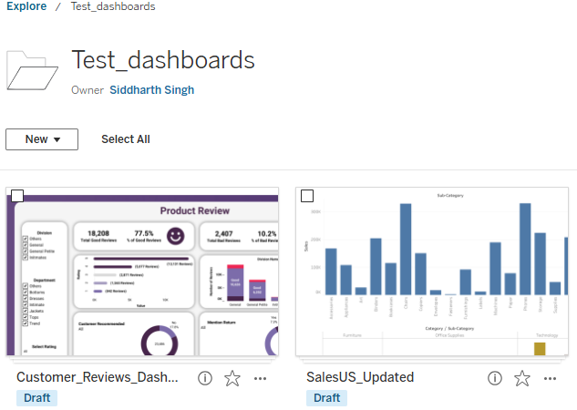

Prepare a CSV Input File
- Create a CSV file containing the following columns:
- <workbook name> → the name of the workbook in Tableau Cloud
- <embedded link> → the direct link to the workbook/dashboard
- This CSV serves as the input for the filter extraction process.
Example:

Download Chrome WebDriver
- Install the Chrome WebDriver that matches your installed Chrome browser version.
- Place the chromedriver.exe (or equivalent binary) in a dedicated folder for easy reference in the code.

Create Local Folders
- Dashboards Folder → for downloading and saving Tableau workbooks from Tableau Cloud.
- Extracted Data Folder → for saving processed metadata and filter outputs (Excel files).
Core Functionality of the code
Workbook Downloading
- Connects to Tableau Cloud. Authenticates & retrieves all workbooks in a project.
- Download them in TWBX format.
Metadata Extraction
- Unzips TWBX and parses TWB XML. Extracts fields, data types, calculations, parameters, connections, sorts, colors, table calcs.
Metadata Conversion
- Regex-Based Transformation: Converts Tableau functions like ZN, IFNULL, DATEPART, RANK, LOOKUP and many more into their DAX equivalents using pattern matching. Conditional Logic Conversion: Converts nested IF and CASE statements into SWITCH (TRUE (), ...) format.
- Sheet-Wise Processing: Processes each sheet independently, ensuring multi-sheet Excel files are fully supported.
Filter Extraction
- Automates Tableau dashboard using Selenium.
- For filters, the script uses embedded links of dashboards to open them in a Chrome browser window using selenium module in python. After opening the embedded link, depending on the dashboard’s ownership, it may require you to sign in. A period of 30 seconds is provided for that. Keep the login ID and password handy for quick log in.
- Opens each sheet.
- Reads the Filters card.
- Produces a structured(CHART | Filters dataset).

Final Output Writing (Excel Export)
- Consolidates metadata and filters into a single Excel workbook
- Creates one sheet per Tableau chart/sheet
- Each sheet contains extracted fields, parameters, connections, and filters
- Ensures outputs are structured, reusable, and ready for downstream Power BI migration
Sample Conversion Table
Tableau Expression | DAX Equivalent
ZN([Profit]) | IF(ISBLANK(Profit]), 0, [Profit])
{FIXED [Region]: SUM([Sales])}
  CALCULATE(SUM([Sales]), ALLEXCEPT ('Table', 'Table'[Region]))
IF [Sales] > 100 THEN "High" | SWITCH (TRUE (), [Sales] > 100, "High")
REPLACE ([Product Name], "Old", "New") | SUBSTITUTE ([Product Name], "Old", "New")
Code Link - Complete_Process_Tableau_to_PowerBI_Migration.ipynb

Time and effort saving analysis
Process Step | Manual Time | Automated Time | Time Saved | Efficiency Gain(%)
Accessing the Workbook | 5–10 minutes | 3 minutes | 2–7 minutes | 40–70% reduction
Extracting Dashboard Details | 30–40 minutes | 2 minutes | 28–38 minutes | 93–95% reduction
Analyzing Calculated Fields | 30–45 minutes | 5 minutes | 25–40 minutes | 83–89% reduction
Conversion – Open Excel & Locate Sheets | 2 minutes | 0 minutes | ~2 minutes | 100% reduction
Conversion – Identify & Convert Expressions | 40–50 minutes | 1–2 minutes | ~39–48 minutes | 95–98% reduction
Conversion – Validate & Save Output | 0 minutes | 15–20 minutes | –15 to –20 minutes (negative saving) | Increased validation overhead
Filter Extraction (per dashboard) | 8-10 minutes | 1–2 minutes | ~7-8 minutes | 90-95 % reduction
Total Estimated Time (per workbook) | ~115–155 minutes | ~40–49 minutes | ~75–106 minutes saved | ~65–68% overall reduction

*Reviewing converted outputs takes less time in the manual path since the logic is applied directly by the user, leaving a minimal need for validation. In contrast, automated conversions often require thorough review to ensure accuracy, as some outputs may need correction or refinement.
Estimated Time Reduction: ~65-70% per file. Scalability Impact for 20 Dashboards:
- Manual effort: ~ 38-52 hours
- Automated effort: ~ 13-16 hours
- Net savings: ~25-36 hours
- This efficiency gain not only accelerates migration timelines but also frees up analysts to focus on higher-value tasks like validation, optimization, and stakeholder engagement.
Challenges & Limitations

Challenge / Limitation | Description | Notes / Examples
Complex Tableau Logic | Certain advanced Tableau logic requires manual review and cannot be fully automated. | Example: Nested LOD expressions like- {EXCLUDE [Country]: MAX(INCLUDE [Order ID], [Country]: SUM([Shipping Cost]))} and Table calculations.
Unmapped / New Functions | Functions not yet defined in the conversion script remain unconverted. | Requires continuous script enhancement to support new Tableau functions.
Cardinality Extraction | Cardinalities cannot be extracted from Tableau dashboards or TWB XML. | Methods attempted:1. Web scraping Tableau Cloud UI → cardinality not exposed in DOM.2. Data-level inference script → unreliable, results did not match Tableau’s actual relationships.

Sample Dashboard Charts Created
Tableau Dashboard Charts  (Source) | Power BI Equivalent Charts  (Target)
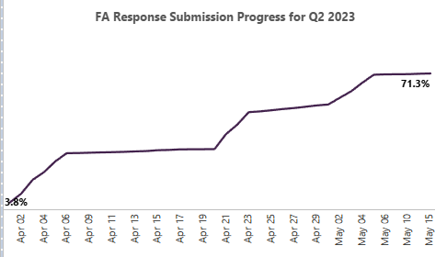 | 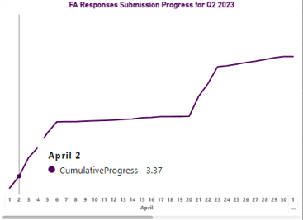
   |   
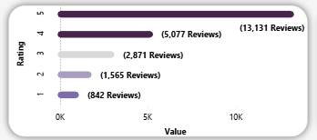 | 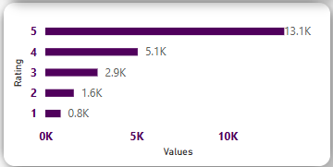
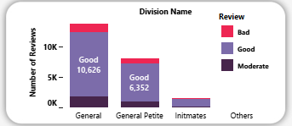 | 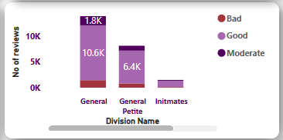
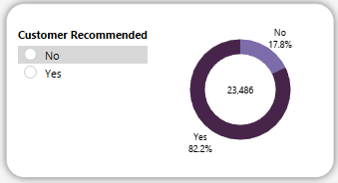 | 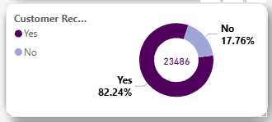
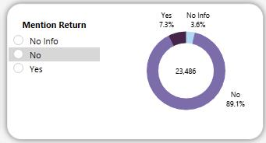 | 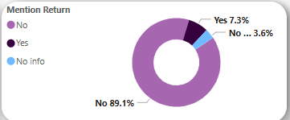
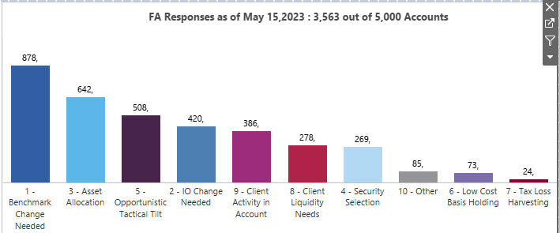

Tableau

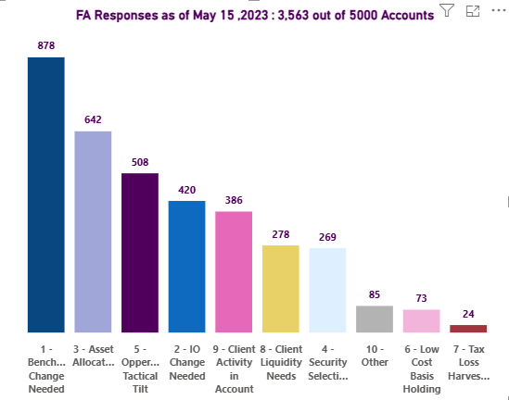

Power BI

